Black Gold League

Team Declaration Meeting – September 25th, 2018 – Percy Page

Attendance: Brian Hoyano (BGL), Jackie Shimko (BGL), Rhonda Kew (BGL), Janice Tymkow (BGL/PEM), Sandra Fenton (BGL), Michelle Madson (PEM), Jeff Morgan (FSK), Kristen Bodnarchuk (SARA), Richard Stahl (HIN), Shannon Langstrom (ERC), Bob Hnatko (PRA), Mike Stuckless (SPK), Darren Poole (SPK), Krista Wood (SGV/BGL), Darrel Pidhirniak (Z5AA), Carla Walker (EFCLRA), Pam Horn (LED), Trent Franson (EFCLRA), Darin Gill (CAS), Brian Pedlar (SGV), Jen Debogorski (RDR), Carolyn Normand (RDR), Sylvie Dubois (BGL-RIC), Chris Wright (BMT), Roxanne Moore (BMT), on phone: Carol Werner (LAC), Shauna Alquist (LAC), Laura Shannon (DVY), late - Jim Cullihall (FMC)
- Call to order - Brian called to order at 7:01pm

- Welcome & Additions to the Agenda – no changes. Motion to adopt the agenda: Krista, 2nd Pam, AIF

- Approval of minutes from August 21, 2018 meeting: 148 teams – no additions or removals. Motion to approve the minutes: Shannon, 2nd Michelle, AIF
- Scheduler’s Report – a) nothing new. A couple changes for division release. Entire schedule to be released on Oct 3rd.
b) Looks like delay in UAA results. U14AA and up start first, and the timing for U10 to start is a week after; U10 schedule will be released last. Hope is that UAA results come in sooner than later. UAA’s are to be reviewed and released, and sent out hopefully Thursday morning. If results match up to declaration today, then no worries.
c) confirm FMC, all teams will travel Oct 13th weekend. They agreed to this, to eliminate stress for Edmonton area teams trying to book busses on short notice. Weekend of the 20th, Edmonton & surrounding are to book travel to FMC. In 2nd session, FMC will travel 1st weekend. FMC to determine which teams (don’t want 16/19 together due to affiliation issues)
Note: Only BGL to supply subsidy for travel to FMC, No FMC subsidy this season. Won’t know re-pooling results until possibly the Monday after re-pooling, so EDM area teams won’t likely travel 1st weekend of 2nd session to FMC – will try to avoid if we can. Should have an idea closer to re-pooling.
- Zone 5 player discussion– Zone 5 AA had a drop in 2 teams – U14AA and U16AA folded this year, due to AA teams forming in other associations.
EFCLRA experienced many requests to join @ U16/U19 – but not enough notice nor space for all of them. Concerned there is a full U16A team worth of players out there without a home. Discussion around the need to consider internal issues, if pulling in players from outside Associations and having internal players quit. Discussion around where to place players after they try out for AA. Discussed issues of ‘shopping around’ for a team, and the havoc it can raise. RAB Policy does not allow Zone teams to host anything but AA teams. Discussion around communicating early on in the season, the need to find homes for players that need somewhere to go. Zone 5 does not feel it will be able to resurrect its U14AA or U16AA teams as it needs feeder of like-minded players – without that, AA is not AA. Discussion about RAB policy and how it allows any Association to house AA. Conversation needs to go to a President’s meeting. Membership expressed the need to come together, to make Zone 5 AA survive, or to find a home for players displaced by current setup.
- Declaration of Teams/Collection of Team Fees
148 teams in total
Vote on U10 pools. Motion to split U10-S1, U10-S2 & U10-S3 in to 2 pools (one black, one gold), reflective of the UAA scores: Brian, 2nd Chris, Sandra abstained
Motion to split U12B & U12C in to 2 pools (one black, one gold) based on UAA scored: Brian, 2nd Chris, Sandra abstained
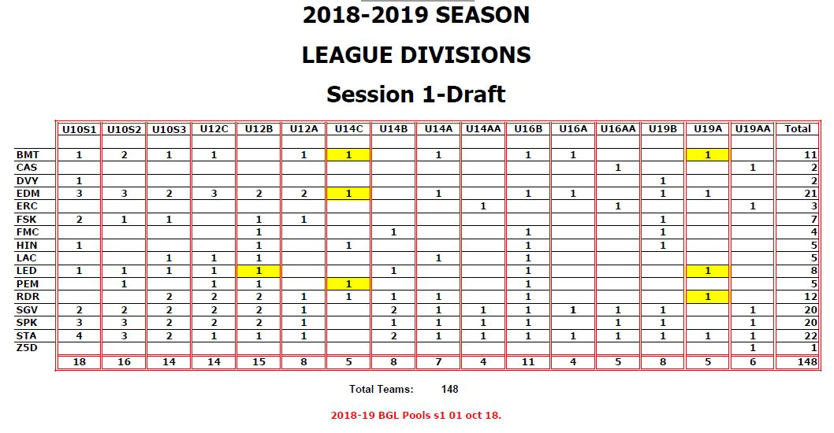
The above will change if UAA scores place teams in different levels (U10-U14).

Only 2 declared U19A teams, owing to 6 U19AA teams, which has emptied the middle division of players. (similar at U16A) At this point not enough for a competitive division. Discussion around pool sizes for U19A and U19B: one large pool, or move some teams up? STA and EDM do not want to play their B teams.
Suggestion for those local Associations with only one team to play with A’s in session 1, reassess in session 2. Those teams joining A pool are: LED-U19B-1, RDR-U19B-1, BMT-U19B-1. Was this a motion?

- Declaration of Overage and male players (U16+)
Overage/Male: BMT: 1 overage on U14 ??
EDM: 3-U14 on U12 (1 on U12B) (2 on U12C)
RDR: overage on U12C, male goalie on U16B
PEM: 2 overages on U12C, 1 overage on U16B
FMC: 3 males at U12
DVY: male goalie at U19
Overage Forms are needed for re-pooling
- Association Round Table:
BMT – tournament Oct 19 weekend, still openings in U10-S1 & S2, 16AA, 19B & Open C
CEN – tournament Dec 14-16, have had lots of applications
DVY – no tournament; needing U19 goalie
EFCLRA – Silver Ring Jan 18-20 for all divisions except U19; need a U14A goalie
ERC – Wood tournament full Nov 24-26
FMC reminder that for tournament, if you register and play, you will get your registration fee back. No one has committed to come yet. May have a hodge podge tournament with GP/PR ringette? Oct 26-28
FSK – tournament Nov 30-Dec 2. Did not submit Association B/O – Sandra was able to confirm
HIN – Oct 26-28 tournament, looking for teams in all divisions
LAC – tournament Nov 16 weekend, looking for teams in all divisions + Open C
LED – Jan 11-13 tournament
PEM – nothing
RDR – Jan 4-6 tournament
SPK – tournament Nov 9-11, only U10-S3 and all U12
SGV – Feb 15-18 tournament, no December tournament. Hoping to have play downs incorporated in to the tournament.
STA – Oct 5 Turkey Ring. Need 2-U14B goalies
Z5 – nothing
Reminder Team Entry for website will go out asap – due at end of month.
Introduced Sylvie Dubois, new RIC. She asked that Associations route any new stuff to her, instead of Terri. She will communicate with Lauren @ RAB.
FMC (on phone) stated that U14/U19 and U12/U16 want to travel together due to affiliate issues. All teams will travel the 1st weekend of 1st session, and one pair as determined by FMC will travel the 1st weekend of 2nd session.
Motion to adjourn 8:48pm: Trent, 2nd Rich, CARRIED
- Next Meeting: Tuesday November 20, 2018 @ Percy Page

